CAS PY 106

In-class Note 15

1. Current-carrying Wire
2. Imagine a piece of wire, with current flowing through it
3. 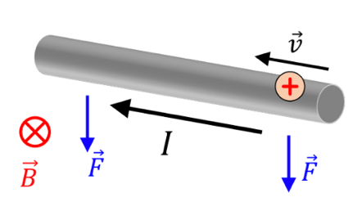

F = I \* L \* B \* sin(theta)

1. Given that magnetic field points toward the screen, direction of force on the wire is Down
2. 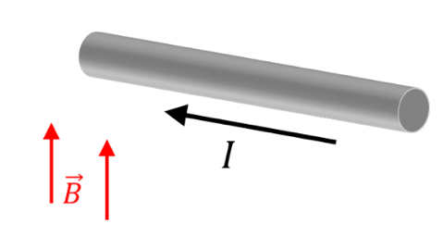
3. Given that magnetic field points upward, direction of force is out of the screen
4. Which way does F point?
   1. A current carrying wire is placed in the magnetic field as shown in the picture below. What is the direction of the force on this wire?
   2. 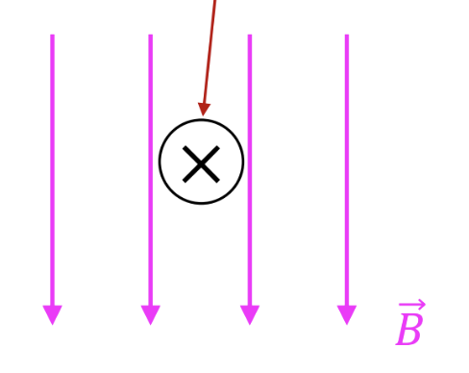
   3. Direction of force on the wire is left
5. Rectangular loop of current
6. 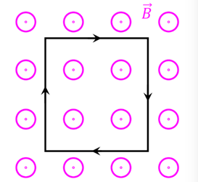
7. There is no net force, it’s zero
8. 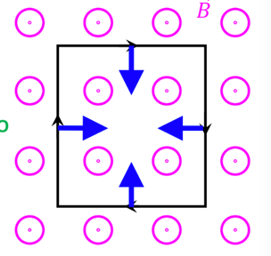
9. Another loop with current
10. 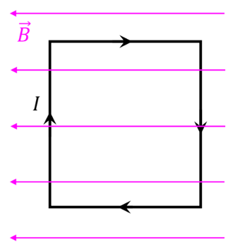
11. Direction of force is zero
12. 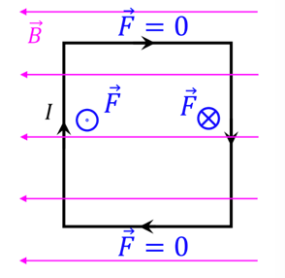
13. But there is a torque
14. Torque on a current loop
15. Two forces are pointing in opposite directions on opposite sides of the loop
16. Torque = T = r \* F = r \* F \* sin(theta)
17. In this example, theta = 90 degrees, so sin(90) = 1
18. Relation between E-fields and B-fields
19. Charges generate E-fields: E = kq/r^2
20. Charges in E-field feel a force: F = qE
21. Moving charges (currents) in a B-field feel a force: F = ILB\*sin(theta)
22. Long straight wire with current: Oersted’s Law
23. Magnetic field lines “encircle” the current carrying wire and lie in a plane perpendicular to wire
24. Reversing direction of current 🡪 reverses direction magnetic field
25. Strength of B field is directly proportional to magnitude of current I
26. Strength of B field at any point is inversely proportional to the distance of the point from the wire r
27. 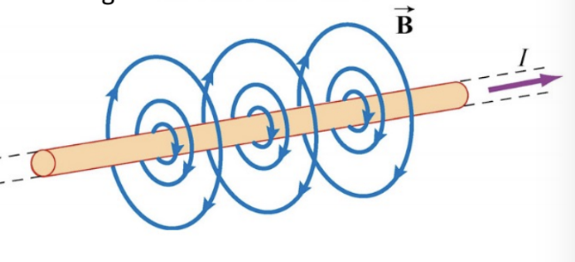
28. Review: right hand rule #2: the “curl” rule
29. 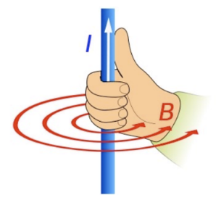
30. Use this rule when one thing goes in circle, and another thing sticks out perpendicular
31. Curve fingers of your right to make circle
32. Thumb = direction of perpendicular thing
33. In this case: current is thumb, B-field is fingers
34. Magnetic field around a long straight wire
35. Magnitude B-field around long straight wire:

Ampere’s Law: B = u \* I / 2pi\*r

Where I = current (in amps)

r = distance between the wire and where you measure your B-field (in meters)

u = permeability constant: 4pi \* 10^-7 Tm/A